
Strengthen your mental resilience and physical well-being.
As an employee, you can rely on a wide range of services and benefits from AG.
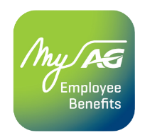
With the MyAG Employee Benefits app, you always have your insurance and services at hand. Download the app to:
- View your coverages.
- Strengthen your mental resilience and physical well-being.
- Enjoy numerous benefits with AG's healthcare partners.
- And much more!
Discover more information on ag.be/en/myageb-app and download the MyAG Employee Benefits app in the App Store or on Google Play.
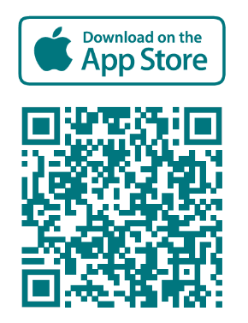 | 