
Medical expenses? Submit them digitally and get refunded quickly!
As an employee, you can rely on your health insurance with AG.
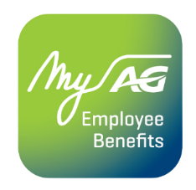
With the MyAG Employee Benefits app, you always have your insurance coverages at hand. Handy when you need them! Download the app to:
- View your coverages.
- Submit your medical costs easily and get reimbursed quickly.
- Have your digital My Healthcare Card scanned at the pharmacy so that AG receives your receipts directly.
- And much more!
Discover more information on ag.be/en/myageb-app and download the MyAG Employee Benefits app in the App Store or on Google Play.
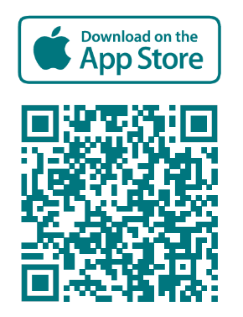 | 