
Hospital admission?
As an employee, you can rely on your hospitalisation insurance with AG.
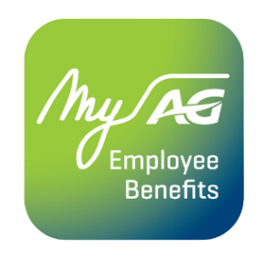
With the MyAG Employee Benefits app, you always have your insurance at hand. Handy when you need them! Download the app to:
- Consult your coverages.
- Report a hospital admission, in advance or on the spot.
- Submit medical expenses related to your hospitalisation.
- And much more!
Discover more information on ag.be/en/myageb-app and download the MyAG Employee Benefits app in the App Store or on Google Play.
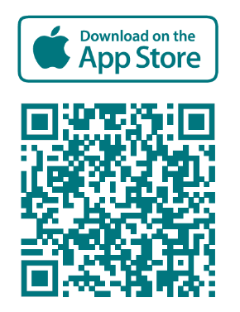 | 

