
Strengthen your mental resilience.
As an employee, you can rely on a wide range of services and benefits from AG.
With the MyAG Employee Benefits app, you always have your insurance covers and services at hand. Download and access the app 24/7:
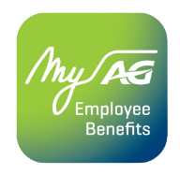
- Test your resilience and receive personalised recommendations.
- Participate in individual and tailor-made programmes.
- Discover inspiring articles and videos from the well-being library.
- Take advantage of the 5 included sessions with a psychologist (per subject and family member) and so much more!
Discover more information on ag.be/en/myageb-app and download the MyAG Employee Benefits app in the App Store or on Google Play.
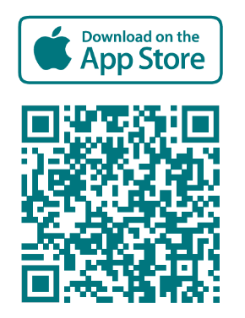 | 