
Check your supplementary pension online.
As an employee, you build up a nice supplementary pension through AG.
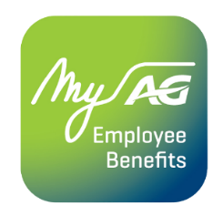
With the MyAG Employee Benefits app, you always have your group insurance at hand. Download the app to:
- View your retirement fringe benefits.
- Simulate your gross and net supplementary pension amount.
- Get an overview of your pension slips.
- And much more!
Discover more information on ag.be/en/myageb-app and download the MyAG Employee Benefits app in the App Store or on Google Play.
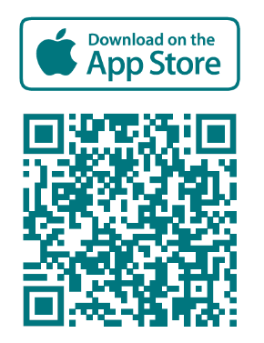 | 

