
Want the latest info about your supplementary pension?
Look no further!
NEW: Introducing the new Pension Benefit Statement
Great news: your employer has had the foresight to set up a supplementary pension plan for you with AG. Until now, you’ve received a benefits statement each year showing the most recent gross value of your pension.
Starting in 2026, this pension statement will be replaced: you’ll receive an annual, new Pension Benefit Statement instead. You will receive this new legal document for the first time at the end of 2026, showing the amounts on 31/12/2025.
This means that you'll no longer be able to view the most recent status of your supplementary pension.
Want to avoid this? No problem!
A view of your supplementary pension at any time
Did you know that you can always check the most up-to-date value of your supplementary pension in MyAG Employee Benefits? And that's not all. It's also your go-to source to:
✔ view your fringe benefits
✔ run a projection of your gross and net supplementary pension benefits
✔ access all of your Pension Benefit Statements
You'll be notified automatically whenever new information becomes available.
Not using the app yet?
👉 Here's how to get started:  ➡ Download the MyAG Employee Benefits app  ➡ Register in a flash via itsme®  ➡ Enter your personal e-mail address in the app  This way, you'll always stay informed and AG can communicate with you directly. | 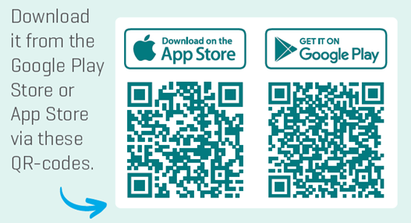
Rather use your computer? You can do that too! Just go to www.myageb.be.
Questions?
For more information, call AG on +32 2 664 07 00 or e-mail us at AGSupport@aginsurance.be.
AG Insurance (abbreviated AG) SA/NV - 53 Blvd. E. Jacqmain, 1000 Brussels - www.aginsurance.be - info@aginsurance.be - IBAN: BE13 2100 0007 6339 - BIC: GEBABEBB - RPM/RPR Brussels - VAT BE 0404.494.849 - Belgian insurance company licensed under code 0079, under the supervision of the National Bank of Belgium, 14 blvd de Berlaimont, 1000 Brussels

