Subject: Your Certificate of Insurance, ready in a few clicks
Dear Staff Member,
Do you need a Certificate of Insurance?
You can easily download it yourself via MyAG Employee Benefits, the platform provided by our insurer AG Insurance, on your smartphone or computer. It’s the quickest and easiest option.
Benefits for you
- available immediately
- no waiting time or intervention required
- accessible 24/7
- always within reach
- securely downloaded in one click and automatically saved as a PDF

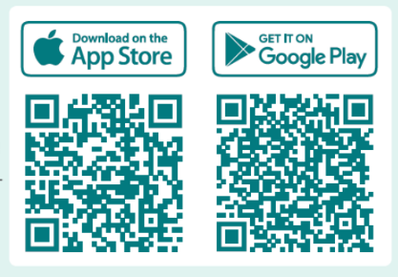
Download the app via the Google Play Store or App Store, or log in and go to "Healthcare" > "My Certificates of Insurance". You can find more information here.
In addition, depending on your coverage, MyAG Employee Benefits offers a range of handy features:
- report a hospital admission
- send in your medical expenses
- project the net value of your group insurance benefits
- view your coverage details
- access services such as My Mind and My Care
Quick, easy and everything clearly organised in one place.
Questions?
Feel free to contact our HR department.
Best regards,

